Trapping Guidelines

Date of Trap Rental: ___________________ Date Trap Due back: ____________________

The Humane Society of Charlotte loans out traps for TNR, the Trap-Neuter-Return of community cats.
Any questions, concerns, or requests for a trap loan extension should be directed to the Community Cat Coordinator at 704-494-7717 or communitycats@humanecharlotte.org.
To schedule a TNR surgery appointment visit: https://humanesocietyofcharlotte.org/health-wellness/trap-neuter-return/

Preparation for trapping
If possible, establish a routine and get the cats used to being fed at the same place and time every day. To ensure that the cats will be hungry, do not feed them before you are going to trap. Be sure to notify others who feed the cats not to leave food out. Hungry cats will be less apprehensive about entering the trap.
You want the cat to be in the trap a minimum amount of time before surgery, so trapping the night before or early morning the day of is usually the best approach. Cats should not eat after midnight the night before surgery.
Prepare the area where you will be holding the cats before and after surgery. A garage or other sheltered, temperature-controlled, protected area is best. Lay down newspapers or absorbent material to catch stool, urine and food residue.
Prepare the vehicle you will use to transport them as well. Putting down plastic is a good extra precaution, but you will need to use newspapers or some other absorbent material on top of the plastic. (Urine will roll right off the plastic and that isn’t what you want.)
Plan your day of trapping carefully. Remember that you may have only one chance to successfully trap an animal. If you trap a cat and release him or her, it is unlikely that you will be able to catch that cat again. They learn very quickly!
If there are young kittens involved, they will not be weaned from their mother until they are four to six weeks of age, and will not be ready for surgery until they are eight to ten weeks of age. If you are trapping a lactating female, try to locate the kittens and see if they are old enough to be weaned. If they are too young, wait until they can eat on their own to trap the mother. The kittens can be included in the TNR program once they are old enough.

Setting the traps
Plan to set traps just before or at the cats’ normal feeding time. Don’t trap in the rain or the heat of day without adequate protection for the cats in the traps. Cats are vulnerable in the traps and could get drenched during storms or suffer from heatstroke in the sun.
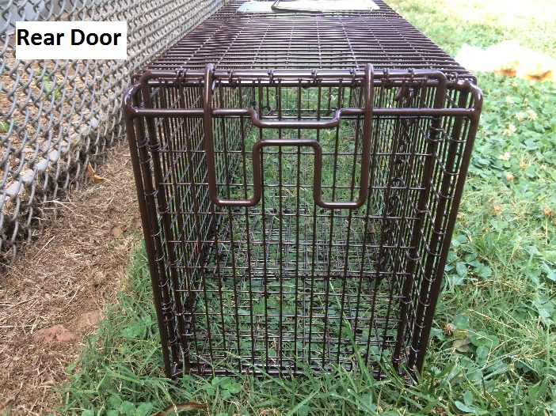
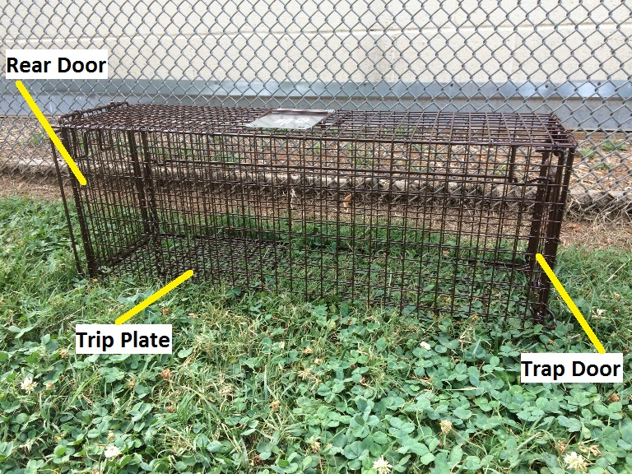
Place traps in the area where the cats usually feed or are regularly seen. Cats are much less likely to enter the trap if it wobbles, so make sure you place the trap on a level surface. If you’re trapping in a public area, such as around your apartment’s pool, try to put the traps in spots where they will not be noticed by passersby (who may not understand that you are not harming the cats).
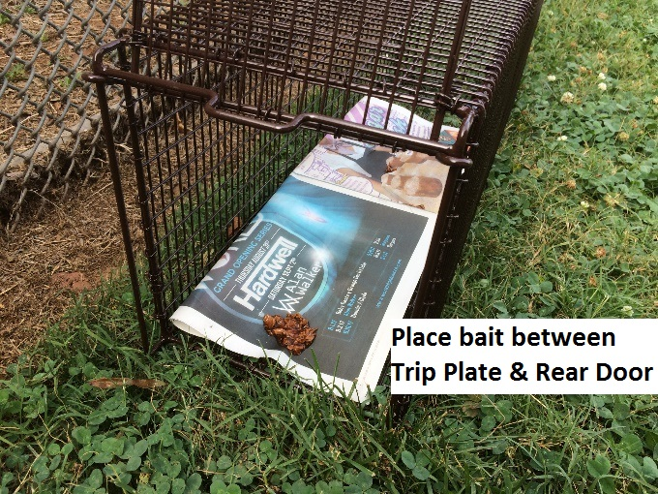
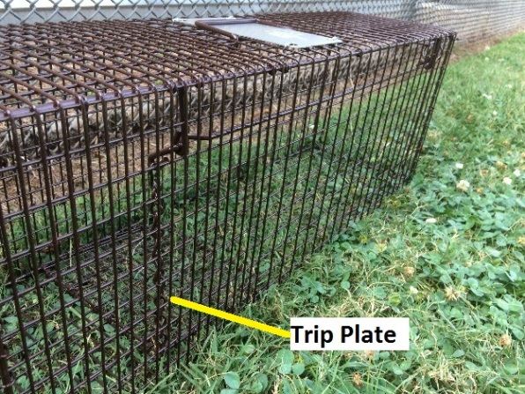
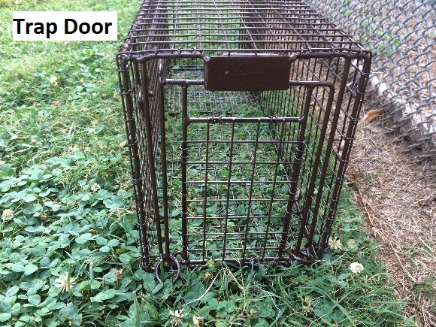
Open the rear door (the one that slides up) and prop it open. You can fold newspaper to line the bottom of the trap and cover the trip plate. Don’t use too much, it can interfere with the trap mechanism, prevent the door from closing properly, or get in the way of clinic staff when they are preparing for surgery. A lining is not necessary, but some cats don’t like walking on the wire.
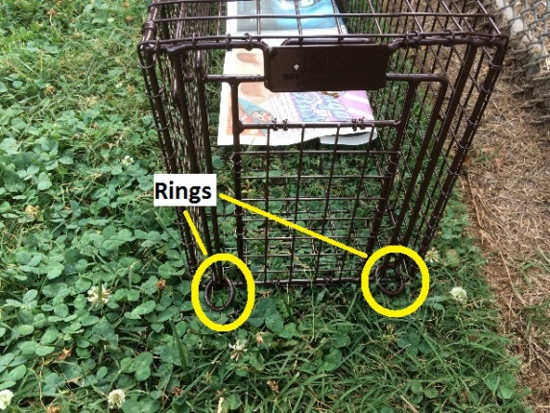
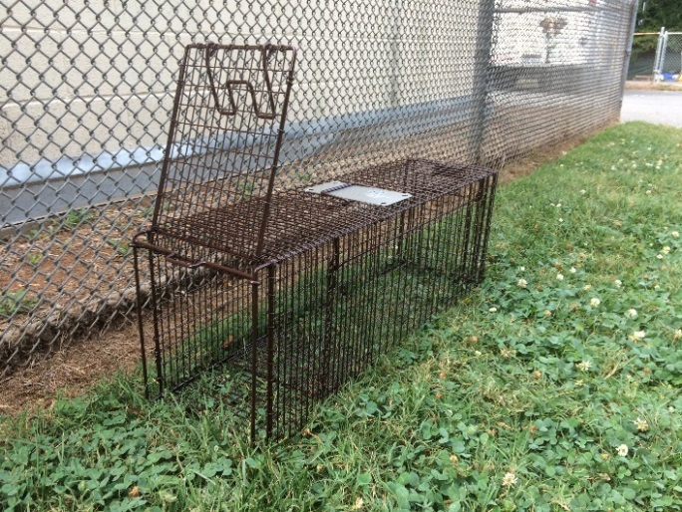
To bait the trap, place a small amount of wet cat food, tuna, or other smelly treat near the back of the trap, between the rear door and the trip plate. You want to make sure the cat will have to walk over the trip plate when it enters through the trap door to get to the food.
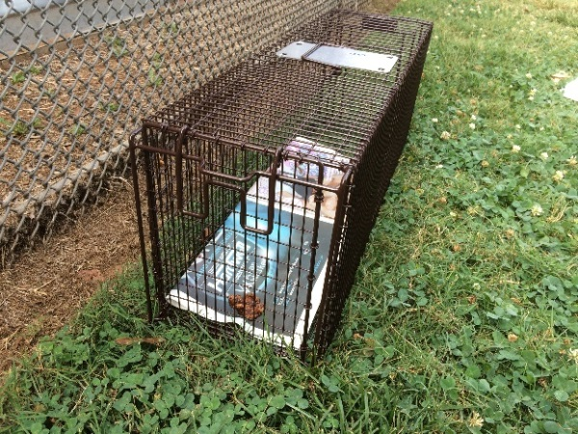
After baiting the trap, close the rear door. Open the trap door at the opposite end by grabbing the rings and pulling up them up. You will then be able to swing the trap door up. Inside the trap, there is a trigger rod which you will rotate 90 degrees so that the trap door can rest against it while open (see photos on next page).

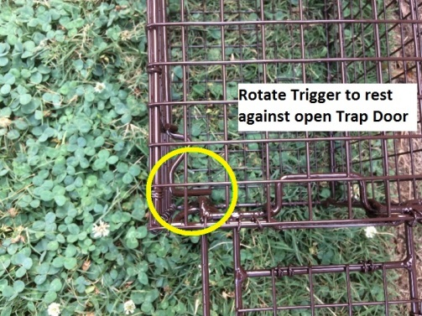
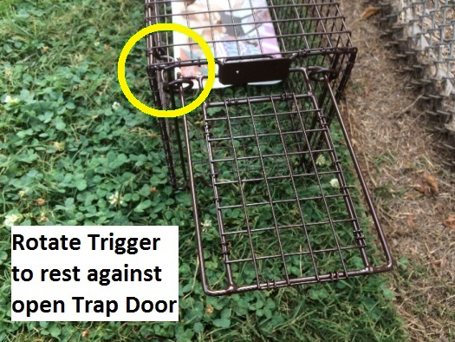
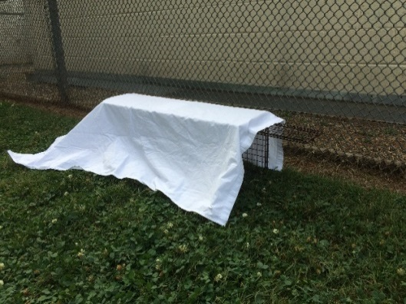
When the cat steps on the plate, it will cause the trigger to release the door and close the trap.
After setting the trap, cover it with a large towel or piece of sheet. Cover the top, sides and back of the trap; fold the material at the front end of the trap to expose the opening. The cover will help to camouflage the trap and serve to calm the cat after he or she is caught.

The waiting game
Never leave traps unattended in an unprotected area because animals are vulnerable after being trapped. Plus, a passerby may release the cat or steal the trap. Don’t hang around within sight of the cats, though, or you will scare them off. Wait quietly in a place where you can see the traps without disturbing the cats, and be patient. If you’re quite a distance away, you can often hear the traps trip.
As soon as the intended cat is trapped, completely cover the trap and remove the trap from the area immediately. Keeping the cat covered will help him to stay calm. He may thrash some, but resist the urge to release him.
When you get the captured cat to a quiet area away from the other traps, lift the cover and check for signs that you have the correct animal and not a pet or a previously neutered community cat. If you note that you have captured a lactating female, check the area for kittens and keep in mind that she must be released as soon as she is awake and alert after surgery so she can care for and nurse her kittens. Cover the trap back up as soon as possible.
If you know or suspect that there are still cats that you have failed to catch and you are their normal caretaker, leave food out for them after you have finished trapping, since they may not have eaten since the last time you fed them.
If you inadvertently catch a wild animal attracted to the food or a cat you didn’t intend to trap (such as one that is ear-tipped and has already been surgically altered), simply release the animal. You can do this by lifting the rear door. Stand behind the trap while doing so, the animal will have a clear route of escape this way.

Holding procedure
After you have finished trapping, you will have to hold the cats in a safe, enclosed location until you can take them to the clinic. This may mean you are holding them overnight if you catch in the evening. Place the cats in the prepared protected area. Keep the cats covered and calm, and don’t feed them. They will remain quiet as long as they are covered. Do not stick your fingers in the traps, try to open the trap, or allow children or pets near the traps. These are often unsocialized animals who will scratch and bite. If you are bitten or scratched do not release the cat. Contact Animal Care and Control through 311. The cat will likely have to be held in quarantine for 10 days unless there is a previous record of vaccinations. This is why it is so important not to reach into the trap.

At the clinic
WARNING: Because these traps are gravity-based and not spring loaded, the trap door will open if the trap rolls. Make sure the trap will not roll during transport, releasing the animal into the car.
Visit our website to schedule a Community Cat TNR surgery appointment.
Bring the cat, still in the trap you caught him in, to the Gary T. deLisser Spay/Neuter Clinic at Animal Care and Control, located at 8315 Byrum Dr, Charlotte, NC 28217. Drop off is between 8-8:30am. You will be able to pick the cat back up that same day after 4pm. Caretakers are allowed to bring up to two cats per day. Cats brought in for TNR surgeries MUST be in a trap; each cat must be in a separate trap.
You will be given more detailed instructions regarding post-surgery care by the facility when you retrieve the cat.

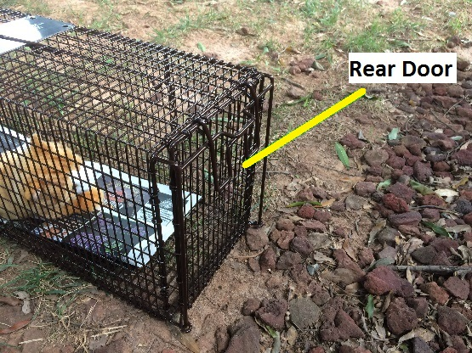
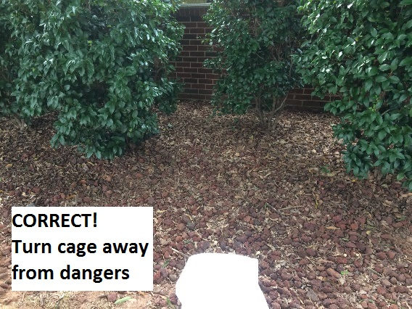
Releasing the cat
Release the cat in the same place that you trapped him or her. Do not relocate the cat; it can be construed as abandonment and the cat may die. It’s common for cats to drive away new cats who appear in their area.
Make sure the release location does not encourage the cat to run toward danger (like a busy street) to get away from you. Always point the trap away from such dangers, like towards bushes or a place the cat would want to hide. Keep the trap covered until you are ready to release the cat. Place the trap on the ground with the rear door facing away from the street or any dangers, remove the cover, and open the rear door by lifting it straight up while standing behind or to the side of the trap. Do not obstruct the cat’s escape route. The cat will probably bolt immediately out of the trap. If that doesn’t happen, tilt the trap so the rear door is slightly up and tap on the back of the trap to encourage the cat to leave. Never put your hand in the trap.
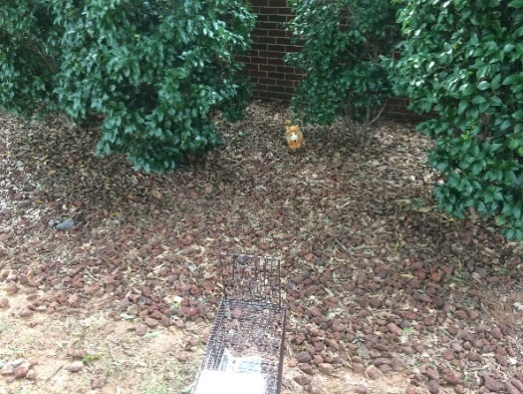
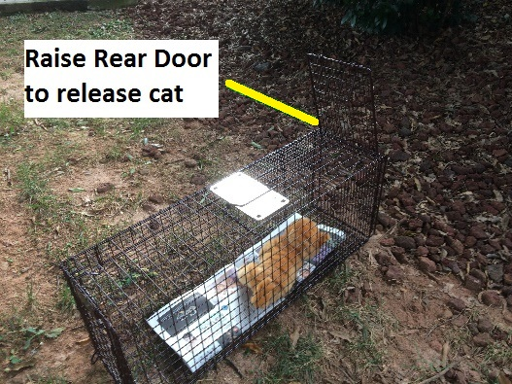
Resume the feeding schedule as usual. You may not see the cat for a couple of days, as he or she may be a little stressed. However, they know where their food source is and will eat when you are not around.

Return empty traps to the Humane Society of Charlotte after you have released the cat.

